Title of the abstract

Author,¹ author²

¹ HERCULES Lab, University of Evora, Largo Marques de Marialva, 7000-809 Evora (PT), email: hello@uevora.pt
² HERCULES Lab, University of Evora, Largo Marques de Marialva, 7000-809 Evora (PT)

The abstracts should not exceed two (2) A4 page. All pictures, diagrams and tables should be included in the text [1]. Arial, 11 pt. should be used as the default font. Single line spacing, justified. The content should clearly state background and objectives, methods used, results, conclusions and keywords [2].

References should be cited by numbers (in the text) and listed at the end of the paper in the order in which they appear in the text [3]. Arial 10pt, single line spacing should be used as the default font.

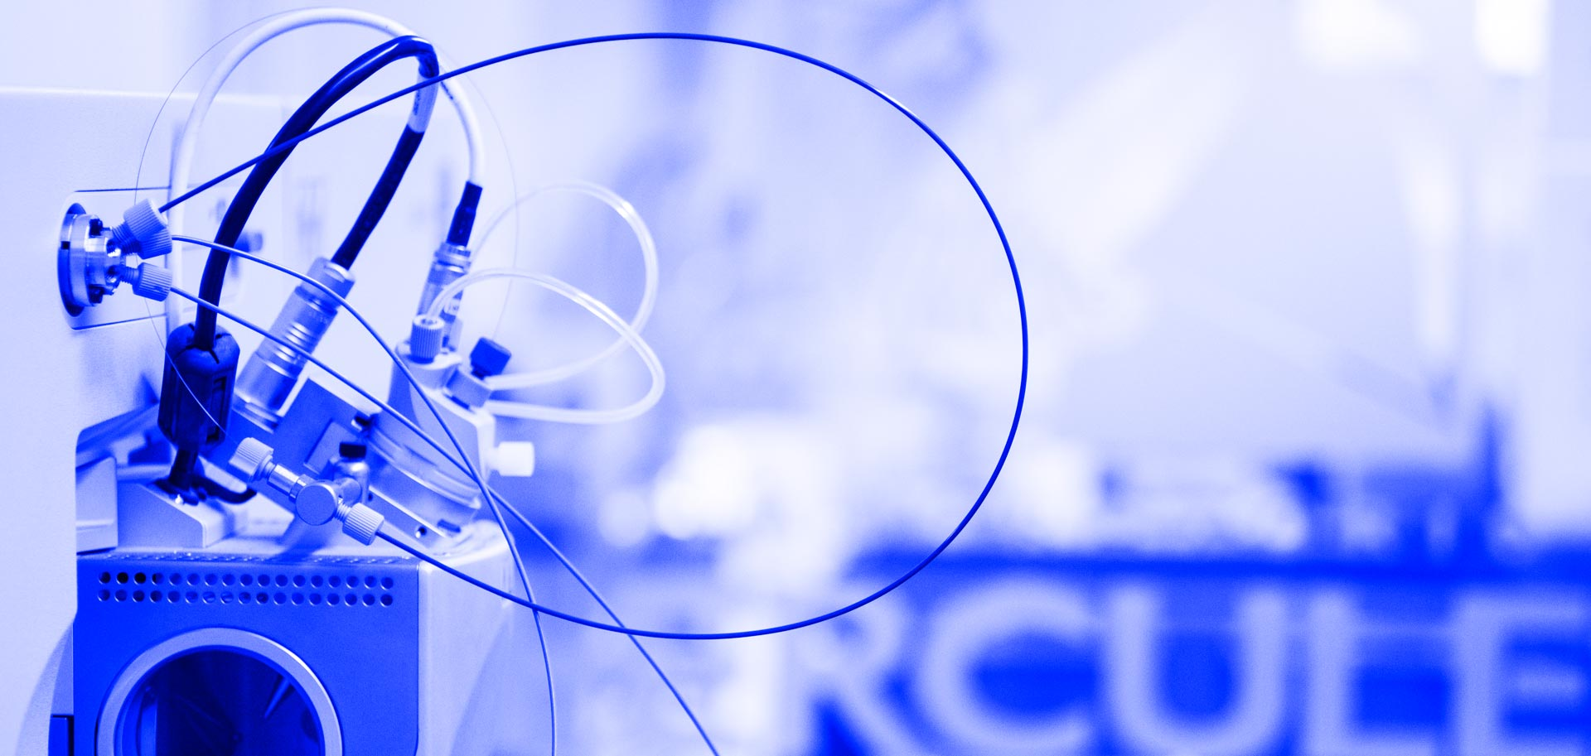
Figure 1/Table 1. No more than two figures/ tables. The caption should be put under the figure in Arial, 10 pt. Black and white and colour photos – 300 dpi.

Acknowledgements

This work has been financially supported by …

References

[1] A. Author, B. Author, . Author, Journal of Journals 1(2), year, page.

